DECLARATION OF FRIENDSHIP
BETWEEN
GREATER MANCHESTER, UNITED KINGDOM
AND
CITY OF OSAKA, JAPAN

Guided by mutual aspiration toward the strengthening of understanding and goodwill between Greater Manchester, England, United Kingdom, and the City of Osaka, Japan, Greater Manchester Combined Authority and the City of Osaka agree to commence discussions for the establishment of Sister City Agreement.
The Sister City Agreement will strengthen the existing bonds of friendship between Greater Manchester and the City of Osaka, and affirm the mutual aspiration to cooperate with each other to foster economic link, innovation, science and technology, environment, education, tourism, culture, sports, and any other areas of interest that benefit both communities.
The two parties will encourage their agencies and relevant local partners to maintain direct contacts with each other for the success of the collaboration.
Both will work together to design and finalize the Sister City Agreement to be signed.

Date: 18 June, 2025

Mayor of Greater Manchester |  | Mayor of Osaka
Mayor Andy Burnham |  | Mayor Hideyuki Yokoyama
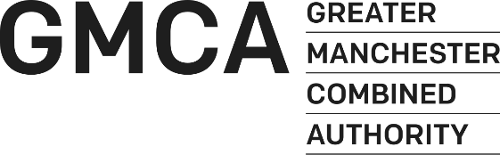 |  | 

