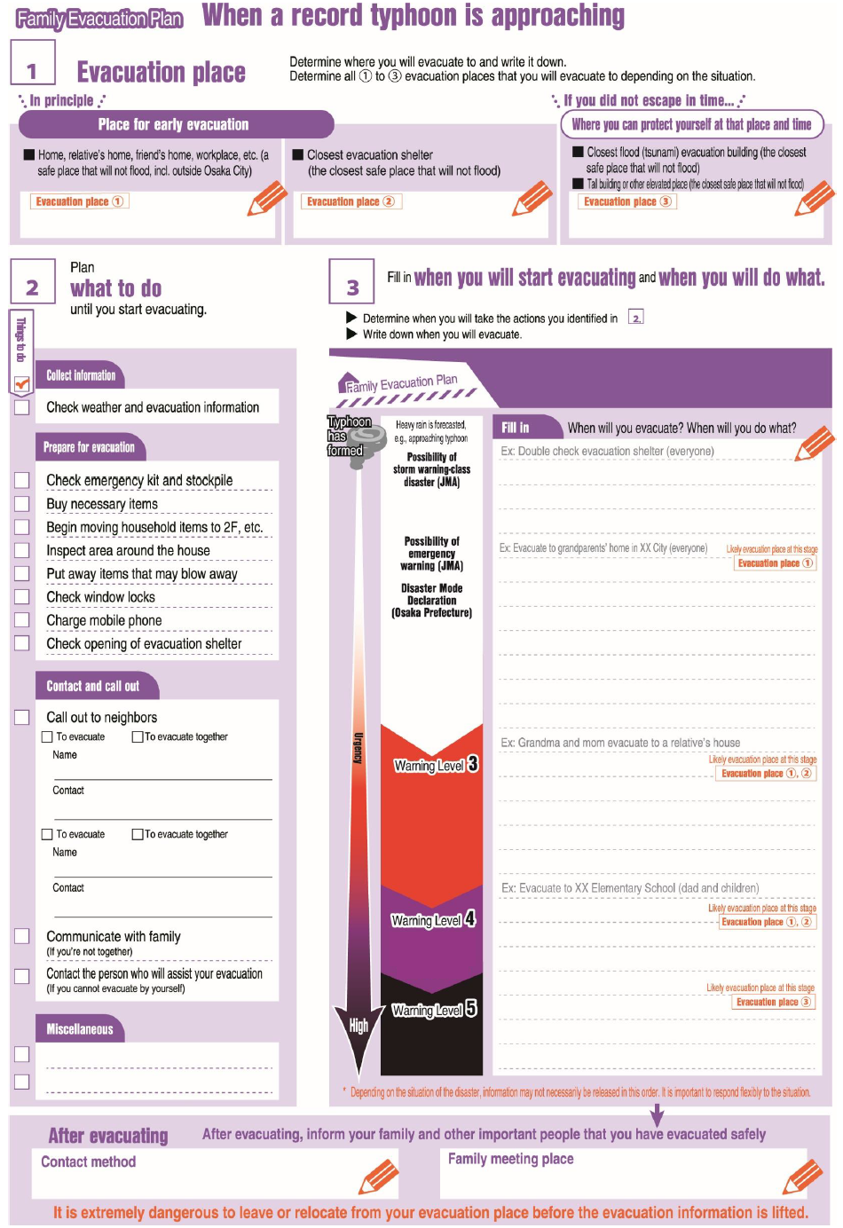

Out of

a dangerous area

**The elderly, etc.**

**should evacuate**

Out of

a dangerous area

**Everyone must evacuate!**

**Ensuring safety during an emergency**